Hello Fellow artists!
I look forward to painting together at Crooked Tree and on location at Sleeping Bear Dunes in the next few weeks!
Painting supplies will be provided but feel free to bring any supplies with which you would like to work. For our painting trip I have a few tips for gearing up lightly.
What you will need:
- Chair…while the cloth ones fold up are convenient they are heavy and I prefer the old aluminum with plastic weaving. (see pic)
- A lightweight TV tray Most important to have a place to set painting supplies. NOT HEAVY WOOD TRAYS.
- Easel…Not essential. Unless it is a watercolor easel that tilts, as you will be painting mostly flat on table or lap.( Light aluminum easel at Hobby Lobby for $20 upright only)
- Umbrella that can clamp onto chair. Though we will look to paint in the shade an umbrella is handy
- Lunch
- Bug Spray ( if you are susceptible)
- Day Pack for art supplies or large Hand bag for gear
Our painting locations will not be strenuous. However, we will be outdoors in the elements which entail a short walk carrying gear, sun, wind, as well as the possibly of rain, bugs, and onlookers. All these things considered it will be the best painting experience ever.
We can check our gear the day before our trip to see who needs what. I will be bringing extra gear, so no stress. Contact me for more info (479)601 2337 or cedarjkindy@gmail.com
See you soon!
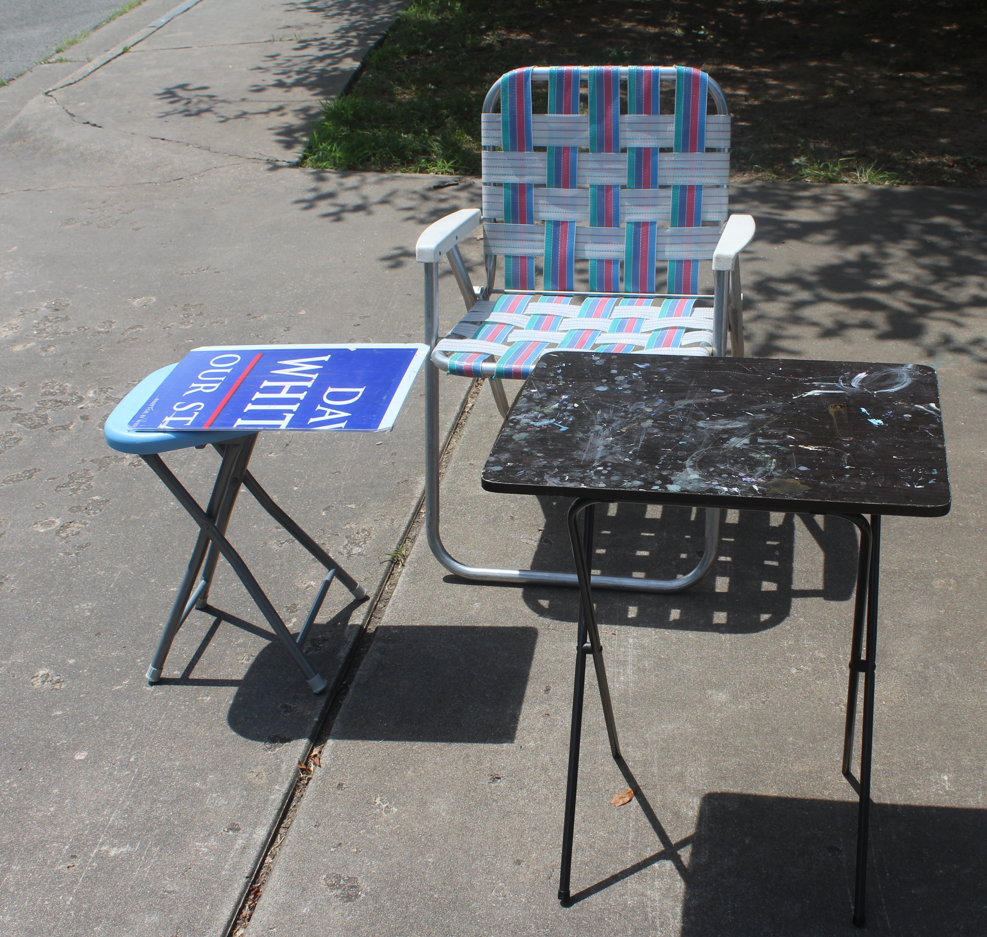
Cedar KIndy
TABLE SUGGESTIONS:
Small Blue stool from Family dollar with boards clamped on (clamp not shown)

Small Brown table from Walmart
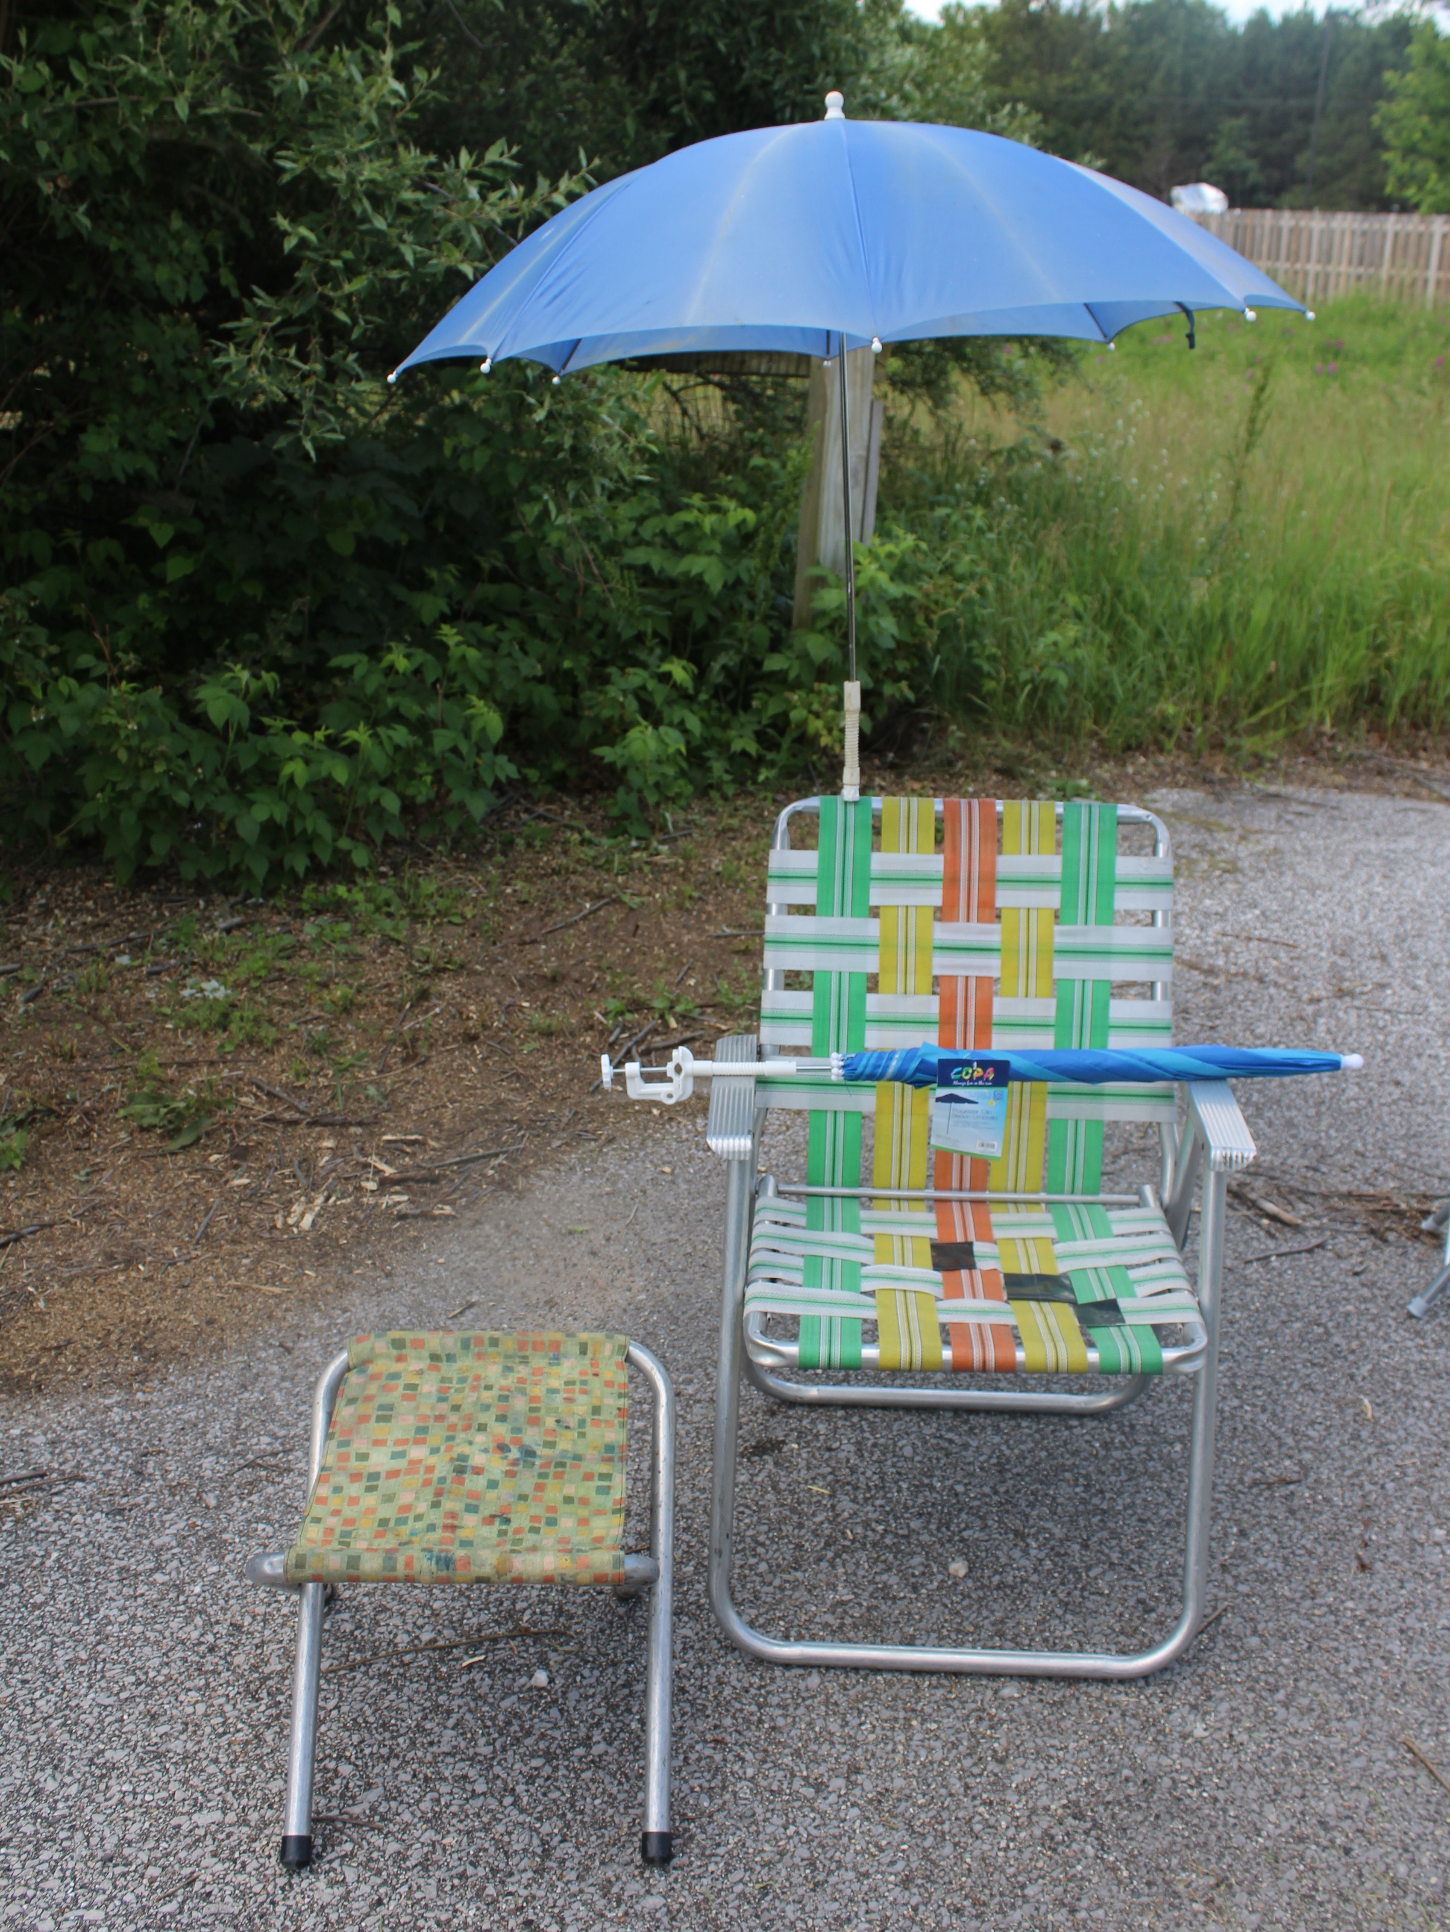
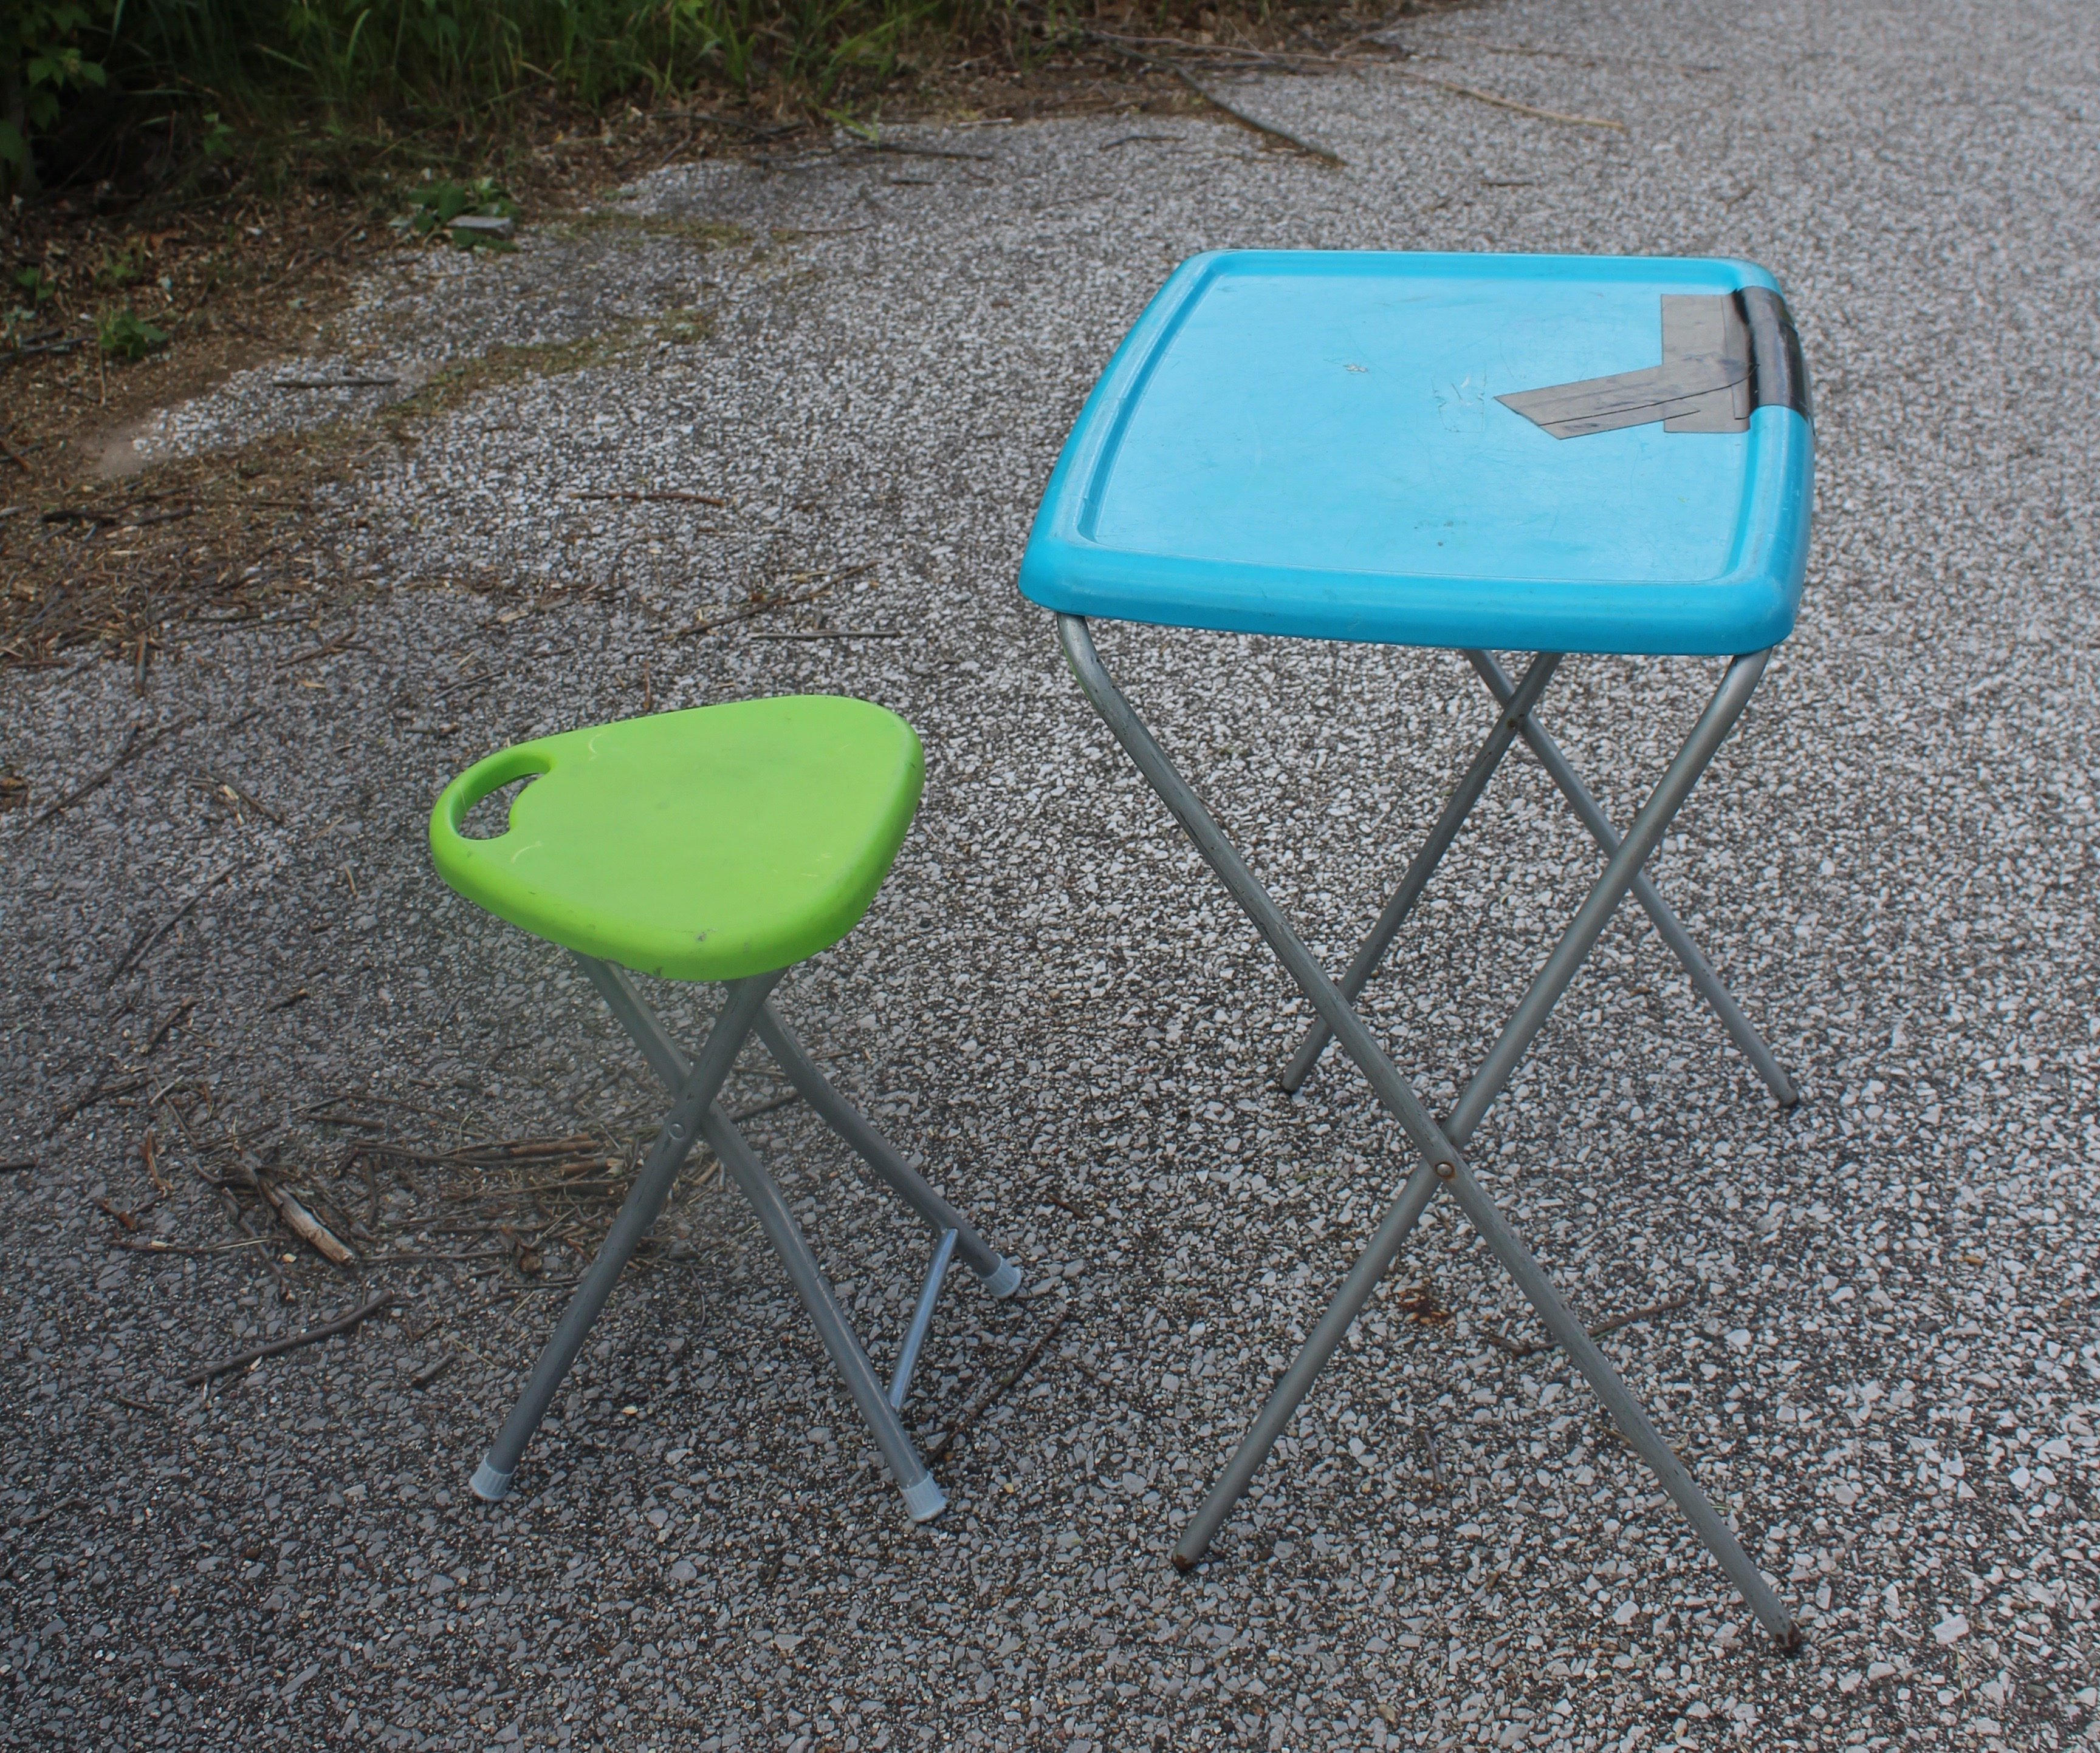
TABLE SUGGESTIONS
Small blue stool from Family Dollar we can clamp board on to make table.(Clamp not shown)
Small brown T V Tray from Walmart
Small green stool from Family Dollar, can convert to table as well
Clamp Umbrella

